Develop a linear regression model for forecasting time
series data
EX:No.4
DATE:22/03/25

AIM:
Write a program to develop a linear regression model for forecasting time series data
ALGORITHM:
Step 1: Install required libraries (if not already installed).
Step 2: Import necessary libraries (pandas, numpy, matplotlib).
Step 3: Load air pollution data, parse dates, and set 'date' as the index.
Step 4: Remove duplicate timestamps and fill missing values.
Step 5: Select the 'pollution_today' column.
Step 6: Remove outliers using the IQR method.
Step 7: Ensure daily data frequency.
Step 8: Resample to weekly average (optional, not used in the plot).
Step 9: Create a figure and plot daily pollution levels as a line graph.
Step 10: Set labels, title, and legend for the plot.
Step 11: Show the plot.

CODE:

import numpy as np
import pandas as pd
import matplotlib.pyplot as plt
from sklearn.linear_model import LinearRegression
from sklearn.metrics import mean_squared_error
# Load the time series data
file_path = r"C:\Users\HARISH\Downloads\accident_time_series_1000_rows.csv"
accident_df = pd.read_csv(file_path, parse_dates=["Date"], index_col="Date")

# Verify column names
if "Total Accidents" not in accident_df.columns:
raise ValueError("Column 'Total Accidents' not found in dataset. Check column names.")
# Select the "Total Accidents" column
time_series = accident_df["Total Accidents"].dropna()
# Convert time series data to supervised learning
def create_lagged_features(data, lag=1):
df = pd.DataFrame(data)
for i in range(1, lag + 1):
df[f"Lag_{i}"] = df["Total Accidents"].shift(i)
return df.dropna()
# Define lag (how many past values to use as features)
lag = 5
supervised_data = create_lagged_features(time_series, lag)
# Split data into training and testing sets
train_size = int(len(supervised_data) * 0.8)
train, test = supervised_data.iloc[:train_size], supervised_data.iloc[train_size:]

# Prepare features (X) and target (y)
X_train, y_train = train.drop(columns=["Total Accidents"]), train["Total Accidents"]
X_test, y_test = test.drop(columns=["Total Accidents"]), test["Total Accidents"]
# Train Linear Regression Model
model = LinearRegression()
model.fit(X_train, y_train)
# Make predictions
y_pred = model.predict(X_test)
# Evaluate model performance
mse = mean_squared_error(y_test, y_pred)
print(f"Mean Squared Error: {mse:.2f}")
# Plot actual vs predicted values
plt.figure(figsize=(12, 5))
plt.plot(y_test.index, y_test, label="Actual", color="blue")
plt.plot(y_test.index, y_pred, label="Predicted", color="red", linestyle="dashed")
plt.xlabel("Date")

plt.ylabel("Total Accidents")
plt.title("Linear Regression Time Series Forecasting")
plt.legend()
plt.grid(True)
plt.show()

OUTPUT:

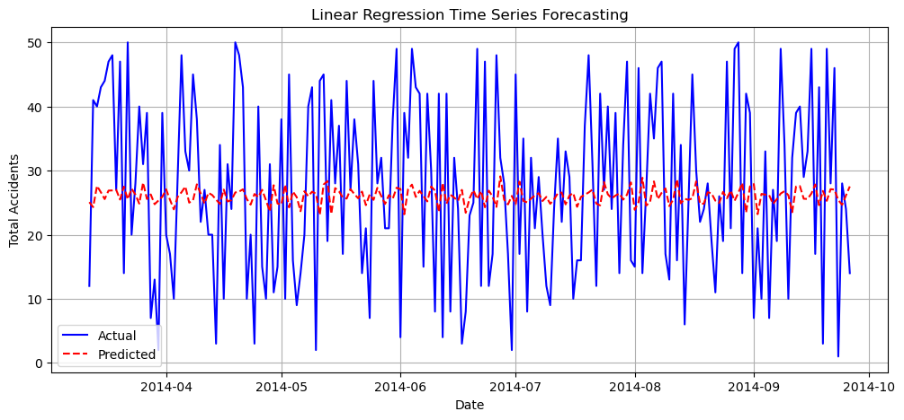

RESULT:
Thus, the program using the time series data implementation has been done successfully.

